**Task 7-GPT**

**Online Fonts**

**Online fonts** are typefaces that can be used on websites via the internet, allowing for greater design flexibility without the need to host font files on your server. Google Fonts is a popular service that provides a vast library of free, open-source fonts that can be easily integrated into web projects.

**Integrating Google Fonts into a Website**

To use Google Fonts in an HTML document, you can follow these steps:

1. **Choose a Font:** Go to [Google Fonts](https://fonts.google.com/), browse the available fonts, and select the one you want to use.
2. **Embed the Font:** After selecting a font, Google Fonts will provide you with a <link> tag that you can include in the <head> section of your HTML document.
3. **Apply the Font in CSS:** You can then use the font in your CSS styles by specifying the font family.

**Example Code**

Here’s an example of how to use Google Fonts in an HTML document:

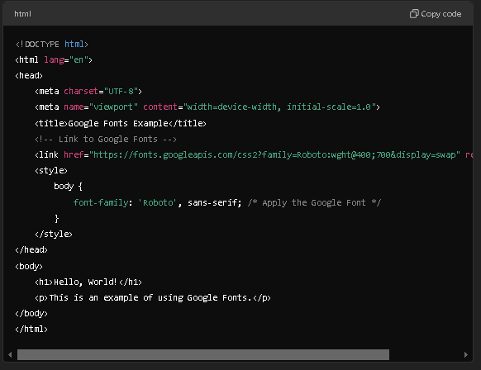

**Result :**

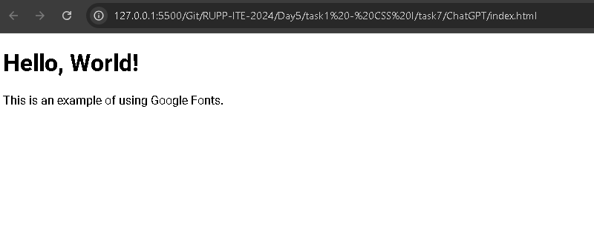

### What is a Favicon?

A **favicon** (short for "favorite icon") is a small icon associated with a particular website, usually displayed in the browser tab next to the page title, in bookmarks, and in other locations. It helps users identify your website easily among multiple tabs and bookmarks.

### Adding a Favicon to a Web Page

To add a favicon to your web page, follow these steps:

1. **Create or Choose a Favicon:** Create a favicon image (typically 16x16 or 32x32 pixels). It’s usually saved in .ico format but can also be in .png or .jpg.
2. **Upload the Favicon:** Upload the favicon image to the root directory of your website or an appropriate folder.
3. **Link the Favicon in HTML:** Add a <link> tag in the <head> section of your HTML document to specify the favicon.

#### Example Code

Here’s an example of how to add a favicon to an HTML document:

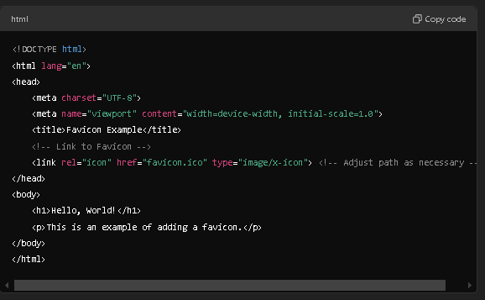

**Result :**

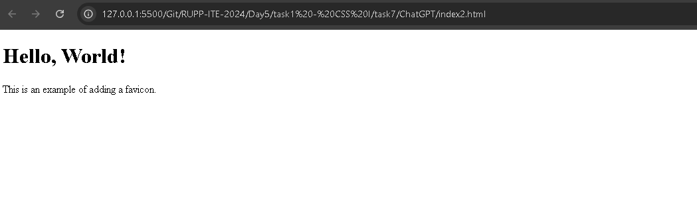

**Summary**

* **Online Fonts**: Fonts hosted on the web, like those from Google Fonts, can enhance web design.
* **Favicon**: A small icon representing your website, improving user recognition.
* **Implementation**: Use the provided HTML code snippets to integrate Google Fonts and add a favicon to your website.